
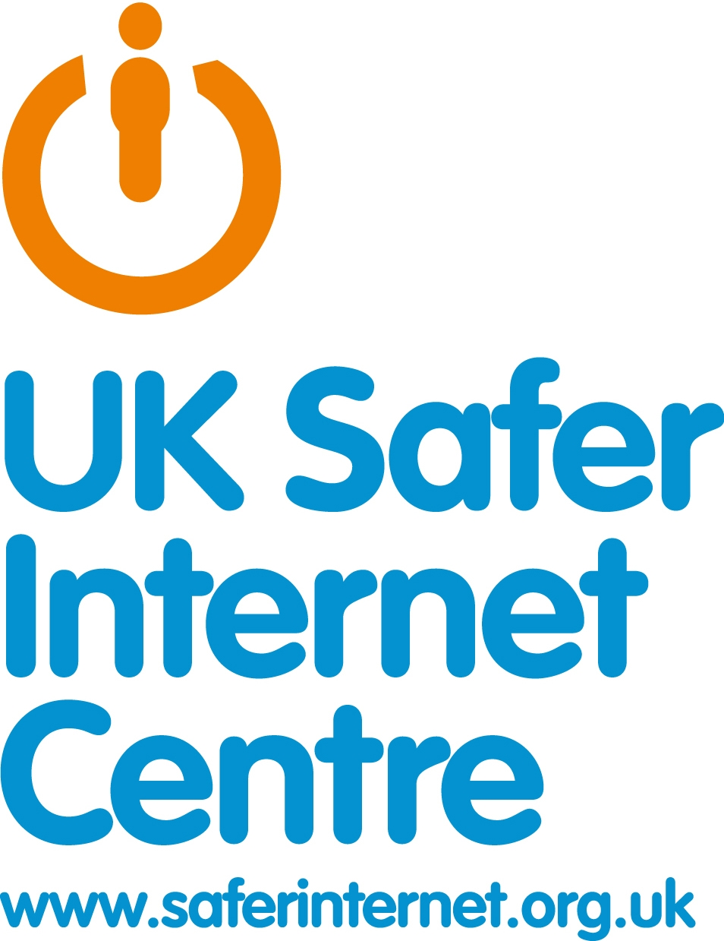

Harm vs Risk

In a group think about the sorts of online risk you think you face.
You may want to consider these topic areas:

1. Identity theft e.g .Facebook hacking
2. Sexting - The distribution of sexual messages or images
3. Cyberbullying – bullying over the internet
4. Viruses – at times you may not even realise your device has been infected!
5. Personal Information abuse - Use of your information in a way you don’t like.
6. Grooming – where an adult deliberately makes contact with a young person in order to lure them into a sexual relationship online or offline
7. Internet addiction
8. Being exposed to extreme content from websites that feature shocking and disturbing images
9. Financial cheating – this could be in the form of email scams

Plot the topic areas against risk ( the likelihood of it happening) and harm (how much harm an individual would encounter).
E.g. You might think the risk of being financially cheated online is relatively low but the harm could be high.
Risk
Harm

