Perfect passwords checklist

My passwords:
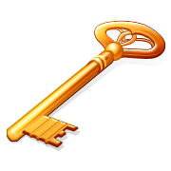

- use letters and numbers
- use a minimum of 8 characters
- don’t contain any personal information
- use characters like brackets, &, or %
- use a mixture of capitals and lower case letters
- use a sentence or a line from a song instead of just one word
- only use the first letters of that sentence
- use different languages
- will be easy for me to remember

- I have different passwords for my online accounts
- I will change my passwords again within the next 6 months

