Resource Pack 1

News Articles

Contents:

1. Ofcom Media Literacy Audit, April 2011 shines a light on parental lack of confidence
2. Quotes from young children across Europe:
What are the risks that worry younger children? EU Kids Online Final Report September 2011

3. Daily Mail article highlighting the number of young children who are left to use the internet unsupervised

4. Quote from an octogenarian user of the internet.

5. Online activities conducted by over 65s

6. Silver surfers warned on Twitter and Facebook fraud
7. Who’s most at risk online?


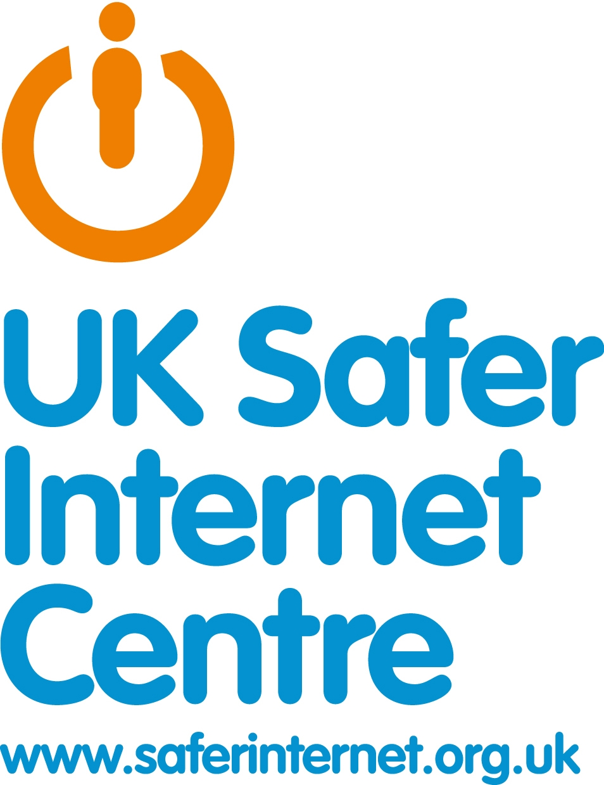

1. Half of parents say they know less about the internet than their children
April 19, 2011
Ofcom Media literacy audit findings
Half of parents (48 per cent) with children aged 5-15 who use the internet at home think they know less about the internet than their children do, new Ofcom research published today reveals. This rises to 70 per cent of parents of 12-15 year olds.
At the same time, there has been increased online activity among children in the past year, including higher usage of mobile and games consoles to go online. Around one fifth (18 per cent) of 5-15 year olds own a smartphone, and 16 per cent go online via a games console. However, among 12-15 year olds this rises to over one third (35 per cent) owning a smartphone and nearly a quarter (23 per cent) going online via a games console. Forty one per cent of this age group now access the internet in their bedroom, up from 31 per cent in 2009.
Parents appear to be less concerned about how their children use the internet. They are less likely to say they have internet parental controls set– 37 per cent in 2010 compared to 43 per cent in 2009. Those that don’t have parental controls mainly say it’s either because they trust their child or because they are supervising them.
The findings form part of Ofcom’s media literacy reports, which focus on the safe and informed use and understanding of digital content among UK adults and children.
http://media.ofcom.org.uk/2011/04/19/half-of-parents-say-they-know-less-about-the-internet-than-their-children/

2. What are the risks that worry younger children?
EU Kids Online Final Report September 2011

“Hacker; spying; cheating; strangers  who contact you online and you do  not really know what they want from  you” (boy, 11, Austria) | “If people put your secrets on the  internet. If people take pictures  or videos of you and put them on  the internet when you don’t want  them to” (girl, 9, Ireland)
“Being hacked by other children online (like: they find out what for instance your password is on an online community)”  (girl, 9, Norway) | “Be made a ridicule by having  personal stuff written about you and  then made public” (boy, 11, Greece)
“Violent video filmed at  school or when somebody is  harmed” (girl, 10, Lithuania) | “Somebody that would ‘crack’ my  password, I mean to access my account,  to impersonate me and to make people  in my contact list believe that I’m lying  to them etc” (girl, 12, Romania)

3. Three-quarters of children aged five use the internet EVERY DAY
By Kate Loveys
Last updated at 9:20 AM on 2nd March 2011
Nearly three quarters of children under the age of five use the internet every day, many unsupervised, an alarming study suggests.
As many as 72 per cent of pre-school children are lured online on a daily basis by sites such as the BBC’s Cbeebies and games like Peppa Pig, the research reveals.
Many parents are allowing their under-fives to explore the web without supervision, leaving them vulnerable to predatory paedophiles.

Online fears: Children as young as three are spending half an hour logged on every day
Child safety experts have reacted with horror, drawing attention to the dangers young web users face.
The alarming revelations also triggered warnings that frequent young surfers may struggle with their learning.
It is feared that spending so much time online will mean they lack reading and writing skills, and scientists believe the glare from the screen may damage the brain development of young children.
Professor Tanya Byron, a clinical psychologist, said leaving a five-year-old unsupervised on the internet is equivalent to ‘abandoning a kid in a shopping centre for a couple of hours’.
She warned: ‘Parents don’t realise they have a responsibility to prepare children for the online world as much as for the real world.
‘A lot of parents haven’t been brought up on the internet and don’t know its dangers.’
Michele Elliott, founder of children’s safety charity Kidscape, said families need educating, adding: ‘Parents don’t realise that predatory paedophiles are trawling the internet, seeking to ensnare young children.’
However many adults seem to think they already know the pitfalls facing young web users, with 88 per cent of parents surveyed saying they were ‘confident’ they understood internet safety issues.
Dr Shirley Atkinson, who analysed the research data, said many parents appear to hold a false belief that they understand the web, while leaving their children unsupervised or failing to install rigorous safeguards.
She added: ‘The most interesting aspect is that parents of under-fives are confident in their ability to protect their children.
‘Ninety-five per cent of parents told us they had a good understanding of the internet.’
The study, conducted by Plymouth Council, surveyed the internet habits of 423 under-fives, with an average age of four.
It found 305 used the internet every day, often unsupervised.
The most used sites were CBeebies and Peppa Pig online games, according to the research.
Daily Mail article Last updated at 9:20 AM on 2nd March 2011

Bottom of Form

4. Silver Surfers are the fastest growing group online

“I’m still with my son and two-year-old grandson, even though they’ve emigrated to Australia – I saw him open his Christmas presents, I was there in the house with them. He came and kissed the screen. It stops you feeling alone.”
Lucy Berry, 80, Age UK Joint Internet Champion of the Year 2010Bottom of Form

5. Online activities conducted by over 65s
Activity | 65+ | All UK
Sending and Receiving Email | 79% | 88%
General Surfing/Browsing the Internet | 78% | 87%
Purchasing Goods/services/tickets | 58% | 71%
Finding/Downloading information for personal reasons | 51% | 58%
Using social networking sites | 59% | 21%
Playing Games online/Interactively | 15% | 38%
To find information on health related issues e.g., NHS Direct | 27% | 36%
Using Local council/Government websites | 31% | 39%
Source: Ofcom Digital Participation Consortium Tech Tracker Q1 2011. Question: Which, if any, of these do you or members of your household use the Internet for whilst at home? Base: Those with access to the Internet at home.

6. Silver surfers warned on Twitter and Facebook fraud

Savvy silver surfers are becoming more familiar with social networking sites such as Facebook and Twitter.
By Kara Gammell
5:02PM BST 06 Apr 2009
Savvy silver surfers are becoming more familiar with social networking sites such as Facebook, Twitter and Friends Reunited. But although charities Age Concern and Help the Aged are encouraging pensioners to become more socially connected online, experts are warning that they could be laying themselves open to fraud.
David Sinclair, head of policy for Help the Aged, said: "Social networking can be a great way for older people to keep in touch with family and friends but as with anything new, it's important to know how to stay safe.
"Older people who use the internet have been shown to spend more time online than any other age group. It's always important to know the risks but there are also plenty of benefits to enjoy."
Here are 9 tips for silver surfers to stay safe on social networking sites:

1 LIMIT IDENTIFYING DETAILS
According to research by Sophos, the data protection experts, 41pc of Facebook users will divulge personal information – such as email address, date of birth and phone number – to a complete stranger, which increases their susceptibility to identity theft.

Details such as phone numbers, pictures of your home, your address, birthday or full name could be used to identify you or locate you offline.
Mr Sinclair said: "Never put sensitive details like your address or banking details on a site. You should also only ever accept to be 'friends' with people you know and trust."
Little bits of information can be used to build up a picture of you that could be misused. A good is only to put on your profile any information you would be happy to have on a park bench – this will help you keep your personal details safe, and private.

2 SET UP A NEW EMAIL ACCOUNT
Set up a separate email account that does not use your real name and use it to register and receive mail from the site. That way, if you want to shut down your connection, you can simply stop using that email account.
To set up an email address, there are free services that are simple and quick to use such as hotmail.com or yahoo.co.uk But try to avoid using an email address that gives away too much information, such as your full name or date of birth.

3 BE CHOOSY ABOUT ACCEPTING FRIENDS
When you join a social network online, it may be tempting to add lots of friends and acquaintances. But approve only friendship requests of people you know and trust, as sometimes fraudsters will set up fake profiles in order to glean information. This is known as social engineering and can be avoided by using the rule – when in doubt, check them out.

4 BE CAUTIOUS OF THIRD-PARTY APPLICATIONS
Many websites of this type offer a range of third-party applications, from games to widgets. But some of these have been shown to be completely fraudulent.
These have been created to install bad software on your computer and access your personal information. A good thing to watch out for is applications that bait you with learning a piece of information by clicking on a button as this generally will initiate a program or virus to install. For example: "Kate has
written some personal information about you. Click here to find how what she said."
Remember that when you click to install an application like that, it not only puts your computer and network at risk, but also potentially sends the same invite out to everyone on your friend list.

5 AVOID USER-GENERATED SPAM
Social networks rely on users to post content such as photos, videos and links and then sharing the content with their contacts. However, there are spam-based programmes that will install bad software if you click on them but may look very innocent, for example leaving a link on your page as a comment.
If it doesn't sound like your friend who left a comment on your social networking page, it very well might not have been, so double check with your friend before you
click on the link.

6 SET YOUR PRIVACY SETTINGS
Social networks are designed to make it very easy for other people to find you. Make sure that your privacy settings are set correctly.
Facebook offers users control of their privacy setting within the "My privacy" section of the site. This can be reached by clicking on the "Privacy" link in the upper right-hand corner of any page on the website. From within the privacy section, you have control of all of your privacy settings and can fine-tune who will have access to your profile and activity on the Facebook website.

7 DON'T BROADCAST YOUR SCHEDULE
Social networking websites allow users to publish their whereabouts to their network of friends. Whether it is a simple status update or detailed itinerary, fraudsters can use this information to victimise you in a number of ways.
One of the biggest mistakes by users is to announce that they will be out of town for a holiday. Criminals use this information to determine when your home may be most vulnerable.

8 BE WARY OF GEOGRAPHICAL NETWORKS
Facebook is made up of thousands of networks worldwide, and users are encouraged to join them in order to meet and make friends with people in their area.
For example, Facebook allows users to join networks which are groups of individuals that share a common trait such as having attended the same school or living in a certain metropolitan area. That means that if you join the network for the city you live in, every other member of that city-based network will have access to your profile information.
Even if you have set up your privacy settings to ensure that only friends can view your information, joining a network automatically opens your profile to every other member of the network. Make sure you change your privacy settings accordingly.

9 CHECK YOUR CREDIT REPORT REGULARLY
By frequently monitoring your credit record, you can spot if someone has been using your identity to obtain credit and then rectify your credit history as soon as possible.
You can get a copy of your credit file for £2 from one of Britain's three credit-reference agencies, Equifax, Experian and Callcredit.
http://www.telegraph.co.uk/finance/personalfinance/consumertips/5115002/Silver-surfers-warned-on-Twitter-and-Facebook-fraud.html

7. Who’s most at risk online?
By John Evelyn on April 21, 2009
Students are placing themselves at the greatest risk of online fraud compared to any other adult demographic in the UK, according to a new study (1) from GetSafeOnline.org.

Highest risk group: Students
Internet users in full-time education (2) are almost twice as confident online as other internet users – more than half (51%) consider themselves ‘very’ internet literate, compared to the national average of 26%. Despite this, they are the most dismissive of the risk of online crime and of the importance of basic security tools (such as anti-virus software) in protecting them against it.
- One in 10 (10%) consider there to be ‘no risk’, more than double the national average (four percent)
- Almost one in three (30%) do not see security software as an important measure, far exceeding the national average of 18%
This apparent complacency translates to their online behaviour, too – students are amongst the greatest culprits in taking unnecessary risks online. For example:
- 28% admit to entering personal details into a website from an unsecured computer, over double the national average of 11%
- Almost one in five (19%) regularly post valuable personal information (such as their date of birth or home address) on social networking sites, almost double the national average (11%)

Lowest risk group: Retired ‘silver surfers’
The lowest risk internet users were those in retirement (3), despite rating themselves as less internet literate than their student counterparts. The largest proportion (40%) consider themselves to be ‘fairly’ literate, acknowledging there are things that they are ‘not sure about’. This moderate level of confidence makes these ‘silver surfers’ much less dismissive of the risk of online crime.
- The majority (55%) believe there is ‘some risk’; only two percent thought there was ‘no risk’
- 89% consider security software a key crime prevention measure, almost 30% higher than the student group
This vigilance also translates to their online behaviour. 70% claim to have never taken any of the common behavioural risks online, such as opening or forwarding attachments from an unknown source (4). This is almost twice the proportion of students (37%) and significantly better than the national average (53%).
http://www.getsafeonlineblog.org/whos-most-at-risk-online

